Index

Chapter | Sr | Topics | Page No
1 |  | Introduction | 7
1 | 1.1 | Company Profile | 7
1 | 1.2 | Introduction to project | 8
1 | 1.3 | Purpose/objective and need of project | 9
1 | 1.4 | Need of project | 11
2 |  | Project Details | 13
2 | 2.1 | System study and Analysis | 13
2 | 2.2 | System design and Requirement | 15
2 | 2.3 | User Interfaces Implementation Details | 16
3 |  | Feasibility study | 18
3 | 3.1 | Technical feasibility | 18
3 | 3.2 | Economic feasibility | 18
3 | 3.3 | Operational feasibility | 18
4 |  | Preliminary Design | 20
4 | 4.1 | Entity Relationship Diagram | 22
4 | 4.2 | Class Diagram | 23
4 | 4.3 | Use-Case Diagram | 24
5 |  | Detailed Design | 25
5 | 5.1 | Introduction | 25
5 | 5.2 | Data Dictionary | 25
5 | 5.3 | Database Design | 25
6 |  | Screen Layout | 29
7 |  | Testing | 41
7 | 7.1 | White Box Testing | 41
7 | 7.2 | Black Box Testing | 42
7 | 7.3 | GUI Testing | 42
8 |  | Scope of project | 43
9 |  | Future Enhancement | 45
10 |  | Conclusion | 47
11 |  | Bibliography | 48

Introduction

Company profile

_____Company Name______ is Registered Private Limited Software Company in Pune. We are working into software development with a reputation for quality, technical skills, and proven, bottom-line results. Our mission is to help our clients leverage IT to solve complex business and technical challenges across the business continuum. _____Company Name______ has an elite workforce of IT professionals on staff. Our objective has been to recruit only the highest caliber and most knowledgeable IT professionals available.
We at _____Company Name______ committed to give cutting-edge services and solutions in software engineering primarily focusing on Java, .Net, SAP, CRM, ERP, Data Warehousing, Middleware, Custom Application Development, Systems Integration, technology- consulting solutions in various IT related industries, with a strong customer focus.
_____Company Name______ is one of the rapidly growing IT company, delivers superior returns to clients through its cost-effective, high-value services model to its clients.
technology services and development of software products. We drive Web Element with the passion of developing solutions that will transform critical and time-consuming business processes into effortless, optimized and productive process with the help of appropriate and advanced software technologies in market. Our wide range of services cover services related to, problem identification, solution conceptualization, drafting, system architecture design, scalable development, system implementation and providing dedicated support to developed solution.

1.2. Introduction To Project

In today's fast-paced and highly competitive travel industry, an efficient and well-structured management system is crucial for ensuring seamless operations and customer satisfaction. As the demand for personalized and hassle-free travel experiences continues to grow, businesses must leverage technology to streamline tour planning, booking, and execution.
Our Tours and Travels is designed to enhance the entire travel lifecycle, from user registration and itinerary planning to secure bookings and customer feedback. By harnessing the power of modern web technologies, our solution provides a robust and user-friendly platform that caters to both travelers and travel agencies.

At the core of our system is its ability to simplify the process of planning and managing tours. Users can explore a wide range of travel packages, customize their itineraries, and book tours with ease. The intuitive interface ensures a smooth user experience, allowing customers to navigate effortlessly through destinations, accommodations, and activities.

Furthermore, our platform integrates secure online payment gateways, ensuring fast and reliable transactions. Whether it's a luxury getaway, an adventure trip, or a business tour, our system provides a seamless booking experience that enhances customer satisfaction.

Beyond customer convenience, the Tours and Travels optimizes backend operations for travel agencies. The platform enables agencies to manage tour packages, monitor availability, and assign travel agents efficiently. By centralizing information, agencies can ensure better coordination, reducing the risk of overbooking and operational inefficiencies.

Additionally, our system fosters real-time communication between travellers, agents, and administrators. Integrated messaging features allow customers to make inquiries, request itinerary modifications, and receive instant updates. This streamlined interaction enhances service quality and builds stronger client relationships.

Recognizing the diverse needs of travel agencies and individual travellers, our system is designed with adaptability in mind. Whether managing small-scale boutique tours or large international travel operations, the platform offers customizable features to align with specific business requirements.
With flexible configurations, agencies can tailor the system to accommodate different travel models, including group tours, solo travel experiences, and corporate travel management. This scalability ensures that businesses can expand their operations without facing technological limitations.

Purpose/Objectives

The Tours and Travels is designed to provide a comprehensive and efficient platform for travel agencies, customers, and administrators to streamline tour planning, booking, and management. By leveraging modern web technologies, this system enhances operational efficiency, improves customer experience, and ensures seamless coordination among all stakeholders. The key objectives of the system are as follows:

Seamless Tour Planning
  - Enable travel agencies to create and manage detailed tour packages, including itineraries, accommodations, pricing, and activities.
  - Allow users to explore, compare, and customize tour options based on preferences and budgets.

Efficient Booking Management
  - Provide a hassle-free booking system that allows users to reserve tours, select dates, and make payments securely.
  - Implement real-time availability tracking to prevent overbooking and ensure a smooth reservation process.

Customer Registration and Management
  - Facilitate user registration for travellers, administrators, and travel agents with secure login credentials.
  - Maintain user profiles with booking history, preferences, and feedback for personalized experiences.

Integrated Payment Processing
  - Support multiple payment gateways (credit/debit cards, UPI, wallets) for seamless transactions.
  - Implement secure encryption and fraud prevention measures to protect financial data.

Real-Time Communication and Support
  - Provide integrated messaging and support features for travellers to interact with agents and resolve queries instantly.
  - Enable automated email and SMS notifications for booking confirmations, reminders, and updates.

Resource and Agent Management
  - Assign travel agents to tours and manage their schedules efficiently.
  - Track agent performance and monitor their assigned tasks for better service delivery.

Transparent Reporting and Analytics
  - Generate detailed reports on tour bookings, revenue, customer preferences, and agent performance.
  - Provide insights through data visualization to help travel agencies optimize their offerings and marketing strategies.

Customization and Adaptability
  - Allow agencies to configure the system based on their unique travel services and business models.
  - Support different travel methodologies, including group tours, solo travel, and corporate packages.

Security and Data Protection
  - Implement access controls to safeguard sensitive customer and business data.
  - Use encryption techniques to ensure the confidentiality of payment and booking information.

Seamless Integration with Third-Party Services
  - Integrate with hotel booking platforms, airline reservation systems, and transportation services.
  - Enable synchronization with CRM and accounting software for streamlined business operations.

Risk and Crisis Management
  - Allow agencies to handle unforeseen circumstances like trip cancellations, refunds, and emergency alerts.
  - Provide automated notifications and contingency plans for travellers in case of disruptions.

Quality Assurance and Feedback Management
  - Implement a review and rating system for customers to share feedback on tours, accommodations, and services.
  - Use customer insights to enhance service quality and address complaints efficiently.

Document and Itinerary Management
  - Enable travellers to access and download important travel documents, including e-tickets, invoices, and itineraries.
  - Maintain a secure repository for travel agency documents, agreements, and operational guidelines.

Time and Expense Tracking
  - Allow travellers to track their expenses during trips for budgeting purposes.
  - Provide agencies with detailed financial tracking for revenue, commission, and operational costs.

By fulfilling these objectives, the Tours and Travels ensures a seamless, efficient, and customer- friendly approach to travel planning and management. The system empowers agencies to enhance their services, optimize resources, and deliver exceptional travel experiences.

Need Of Project

The need for a Tours and Travels arises from the increasing demand for efficient, seamless, and technology-driven travel solutions. As the travel industry expands, businesses require a robust system to streamline operations, enhance customer experience, and optimize resource management. Here are the key needs that this project aims to address:

Efficient Tour Planning and Execution
As travel itineraries become more complex, there is a growing need for a structured system that can assist in planning and managing tours efficiently. The Tours and Travels provides a platform for travel agencies to create, customize, and manage tour packages while ensuring smooth execution and seamless customer experience.

Seamless Booking and Reservation Management
Manual booking processes often lead to errors, delays, and double bookings. This system automates reservations, enabling travellers to search, compare, and book tours effortlessly while ensuring real-time availability updates. It also integrates secure payment gateways for quick and reliable transactions.

Customer Engagement and Communication
In a competitive industry, personalized customer interaction is crucial. This system enhances real- time communication between travellers, agents, and administrators via integrated messaging, automated email notifications, and customer support channels. This ensures quick issue resolution and better engagement.

Resource and Agent Optimization
Efficient resource allocation is critical to ensuring successful tour operations. The system helps in assigning travel agents, scheduling transportation, and managing accommodation logistics, thereby optimizing resource utilization and preventing operational inefficiencies.

Transparency and Accountability
Travel agencies require visibility into their operations, customer preferences, and financial performance. The system provides real-time insights into bookings, revenue, and customer feedback, ensuring transparency and helping businesses make data-driven decisions to improve service quality.

Risk Management and Mitigation
Travel involves inherent risks such as cancellations, weather disruptions, and emergencies. This system integrates risk management features by offering cancellation policies, automated refund processing, emergency alerts, and contingency planning to handle unexpected disruptions effectively.

Documentation and Compliance
Managing travel-related documents such as tickets, invoices, permits, and contracts is crucial for agencies and travellers. The system ensures proper storage, organization, and version control of all essential documents while maintaining compliance with industry standards and regulations.

The Tours and Travels is essential for modernizing travel agency operations by automating bookings, optimizing resources, enhancing customer communication, and ensuring transparency. By addressing these key needs, the system enables travel businesses to deliver seamless, efficient, and customer-centric travel experiences while improving operational efficiency and probability.

System Study and Analysis

System study and analysis are crucial phases in the development of any software project, including the Tours n Travel. This process involves understanding the current travel booking system (if any), gathering requirements, and analyzing them to define the objectives, scope, and constraints of the project. The following steps outline the system study and analysis phase:

Understanding the Current System (If Any)
    - Evaluate any existing tour and travel management systems used within the organization.
    - Identify strengths, weaknesses, opportunities, and challenges associated with the current system.
    - Gather feedback from customers, travel agents, and administrators to understand pain points and limitations in the booking, payment, and itinerary management processes.

Gathering Requirements
    - Conduct interviews, surveys, and discussions with travel agencies, tour planners, and customers to gather requirements.
    - Identify key functionalities such as tour package creation, hotel and flight booking, customer registration, itinerary management, and payment processing.
    - Document requirements using techniques such as use cases, user stories, and requirement specifications to ensure clarity and completeness.

Analyzing Requirements
    - Analyze the gathered requirements to ensure completeness, feasibility, and consistency.
    - Prioritize requirements based on their impact on user experience, business efficiency, and customer satisfaction.
    - Identify dependencies, conflicts, and potential trade-offs between different requirements.
    - Define acceptance criteria to validate that the system meets user expectations effectively.

Defining System Objectives and Scope
    - Clearly define the objectives of the Tours and Travels, including improving customer convenience, automating booking processes, and streamlining operations.
    - Establish the scope of the system, outlining key features such as:
      - Online Tour Package Management (customizable tours, predefined packages)
      - Real-time Booking System (hotels, flights, transportation)
      - User Registration & Profiles (travel agents, customers, admin)
      - Payment Gateway Integration (secure transactions, invoicing)
      - Customer Support & Feedback Mechanism
    - Clearly define what the system will and will not do to manage stakeholder expectations and avoid scope creep.

Identifying Constraints and Assumptions
- Identify potential constraints such as budget limitations, regulatory compliance (travel policies, tax laws), and technical challenges (integration with third-party services).
- Document key assumptions related to user adoption, payment gateway security, and data protection compliance.
- Documenting System Study and Analysis Findings
- Compile all findings into a System Requirements Specification (SRS) document.
- Ensure the document accurately reflects stakeholder needs, business objectives, system scope, and constraints.
- Review the documentation with stakeholders to validate requirements and ensure alignment with business goals and customer expectations.

System Study and Requirement

    - Requirement Analysis
Hardware Requirement:

      - Processor: Intel Pentium 4 or above
      - Hard Disk Utilization: 20 GB or above
      - Input Devices: Keyboard or Mouse
      - Ram: 2GB or above

Software Specification:
      - Browsers: - Chrome

      - Frontend: - Html, CSS, Bootstrap, JavaScript,

      - Backend: - ASP.NET, C#
      - Databases: - MySQL

      - OS: - Windows XP

      - Runtime Environment: -

        - Web Browser: Internet Explorer 6 or above, Chrome, Microsoft Edge

2.3. User Interfaces Implementation Details

Designing and implementing the UI for a Tours and Travels involves creating an interactive and user-friendly interface that allows users to browse, book, and manage their travel plans seamlessly. Below are the key implementation details:

Wireframing and UI Design
  - Create wireframes and mock-ups to visualize the structure, layout, and flow of the web pages.
  - Design the UI with a focus on intuitiveness, user-friendliness, and accessibility.
  - Use consistent colour schemes, typography, and spacing to enhance readability and visual appeal.
  - Ensure the interface is responsive for different screen sizes, including desktops, tablets, and mobile devices.

Choosing UI Components and Frameworks
  - Use ASP.NET (C#) Web Forms or MVC for backend integration.
  - Utilize Bootstrap for responsive design and modern UI elements such as buttons, forms, modals, and navigation menus.
  - Implement jQuery and JavaScript for interactive features like animations, form validation, and dynamic content loading.

Layout and Navigation Structure
  - Use Master Pages or Layout Pages in ASP.NET to maintain a consistent layout across all pages.
  - Design a user-friendly navigation bar with links to key sections like Home, Destinations, Packages, Bookings, and Contact Us.
  - Implement Bootstrap Grid System to ensure proper alignment and responsiveness.

Implementing User Interactions and Event Handling
  - Add event-driven functionalities in ASP.NET using C# code-behind for handling user interactions such as:
  - Booking a tour package.
  - Filtering packages by destination, price, or duration.
  - Contact form submission and email notifications.
  - Use AJAX and jQuery to make the interface dynamic and reduce page reloads for better user experience.

Database Connectivity and Data Binding
  - Bind UI elements (tables, forms, dropdowns) to the SQL database using Entity Framework or ADO.NET.
  - Populate UI components dynamically with travel package details, booking history, and user profiles.
  - Implement data validation on forms to ensure correct user inputs (e.g., valid email, phone number, date selection).

Customization and Theming
  - Allow users to customize their UI experience by selecting themes, font sizes, or language preferences.
  - Use CSS and Bootstrap themes to offer multiple layout options such as light/dark mode.

Localization and Internationalization
  - Implement multi-language support to cater to international users.
  - Store localized content in resource files and retrieve data dynamically based on user preferences.
  - Format dates, currency, and numbers based on the user's region and language settings.

Testing and User Feedback
  - Conduct thorough testing of the UI to ensure usability, responsiveness, and cross-browser compatibility.
  - Perform unit testing, integration testing, and user acceptance testing to validate the system under different scenarios.
  - Gather feedback from users through surveys or beta testing to identify areas for improvement.
By following these implementation details, the Tours and Travels will provide a seamless, engaging, and efficient user experience. A well-designed UI enhances usability, encourages customer engagement, and simplifies tour booking and management, ensuring users can plan their trips effortlessly.

- ​Feasibility Study

Before developing the Tours and Travels web application in ASP.NET, conducting a feasibility study is essential to assess its viability, benefits, and potential challenges. Here's an overview of the feasibility study for the project:

Technical Feasibility:
    - Evaluate the feasibility of implementing the Tours and Travels using ASP.NET, considering factors such as the availability of the required technology stack (ASP.NET, C#, SQL Server for database, HTML/CSS, JavaScript, Bootstrap for frontend).
    - Assess the scalability, performance, and reliability of ASP.NET-based solutions for handling expected workloads, user concurrency, and data processing requirements such as booking management, payments, and user authentication.
    - Determine whether the development team possesses expertise in ASP.NET, UI/UX design, database management, API integration, and security protocols to successfully implement the project.

Financial Feasibility:
    - Estimate the project budget required for development, including costs for server hosting, database management, payment gateway integration, security measures, and ongoing maintenance.
    - Evaluate the potential return on investment (ROI), considering revenue streams such as commission on bookings, premium memberships, advertisements, and affiliate marketing.
    - Compare the cost savings from automation of tour bookings, reduced manual work, and improved operational efficiency.

Operational Feasibility:
    - Assess how the Tours and Travels system integrates with existing travel agency operations, including managing users, bookings, payments, and travel packages.
    - Identify potential barriers to adoption, such as training needs for employees, resistance to change, and integration challenges with existing third-party systems (e.g., hotel and airline booking systems).
    - Analyse the impact of deploying the system on day-to-day operations, including customer service efficiency, travel package customization, and overall booking process optimization.

Legal Feasibility:
    - Ensure compliance with laws and regulations related to travel bookings, payment processing, and data privacy (e.g., GDPR, PCI DSS for secure transactions, and consumer protection laws in various countries).
    - Assess legal requirements for user data storage, international travel policies, refund and cancellation policies, and liability coverage for travellers.
    - Identify potential legal risks, such as disputes over bookings, fraud prevention, and contract agreements with hotels, airlines, and local tour operators.

Market Feasibility:
    - Conduct market research to evaluate demand for online travel booking platforms in target markets (e.g., domestic travellers, international tourists, business travellers).
    - Analyse the competitive landscape, identifying key competitors like MakeMyTrip, Expedia, and TripAdvisor, and opportunities for differentiation through unique features like AI-based recommendations, exclusive tour packages, or customer loyalty programs.
    - Validate the need for specific features (e.g., itinerary management, real-time booking status, customer reviews, and chatbot support) through surveys, feedback from travellers, and travel agency stakeholders.
Based on this feasibility study, stakeholders can make informed decisions on whether to proceed with the development of the Tours and Travels. If the study indicates favourable feasibility across technical, financial, operational, legal, and market aspects, the project can proceed to planning and implementation with confidence. Conversely, if significant challenges are identified, stakeholders may need to adjust the project scope, objectives, or technical approach to enhance viability and mitigate risks.

4.1. Entity Relationship Diagram

Creating an Entity Relationship Diagram (ERD) for an employee management tool system in Java involves identifying the main entities in the system and their relationships. Here's a simplified ERD for an employee management tool system:

Entities and Attributes:

Users
  - UserID (Primary Key)
  - Name
  - Gender
  - LanguagesKnown
  - DOB
  - Email
  - Mobile
  - Address

Admin
  - AdminID (Primary Key)
  - Email
  - Password

Login
  - Email
  - Password

Bookings
  - BookingID (Primary Key)
  - CustomerName
  - BookingDate
  - Status
  - UserID (Foreign Key → Users.UserID)

Packages
  - PackageID (Primary Key)
  - PackageName
  - Duration
  - Distance
  - Package Type

Relationships:
- Users - Login: One user can log in to the system.
  - Relationship Type: One-to-One
  - Foreign Key: Email in Login table

- Admin - Login: An admin can log in to the system.
  - Relationship Type: One-to-One
  - Foreign Key: Email in Login table
- Users - Bookings: A user can make multiple bookings.
  - Relationship Type: One-to-Many
  - Foreign Key: UserID in Bookings table

- Bookings - Packages: A package can be associated with multiple bookings.
  - Relationship Type: One-to-Many
  - Foreign Key: PackageID in Bookings table (if applicable)

Tours and Travels - Management of Bookings and Packages:
  - Relationship Type: One-to-Many (A system can manage multiple bookings and packages).

Diagram

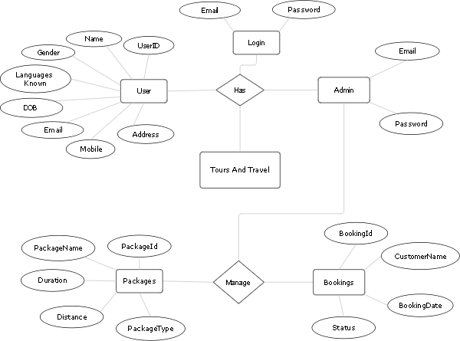

ER Diagram Tours and Travels

​Class Diagram

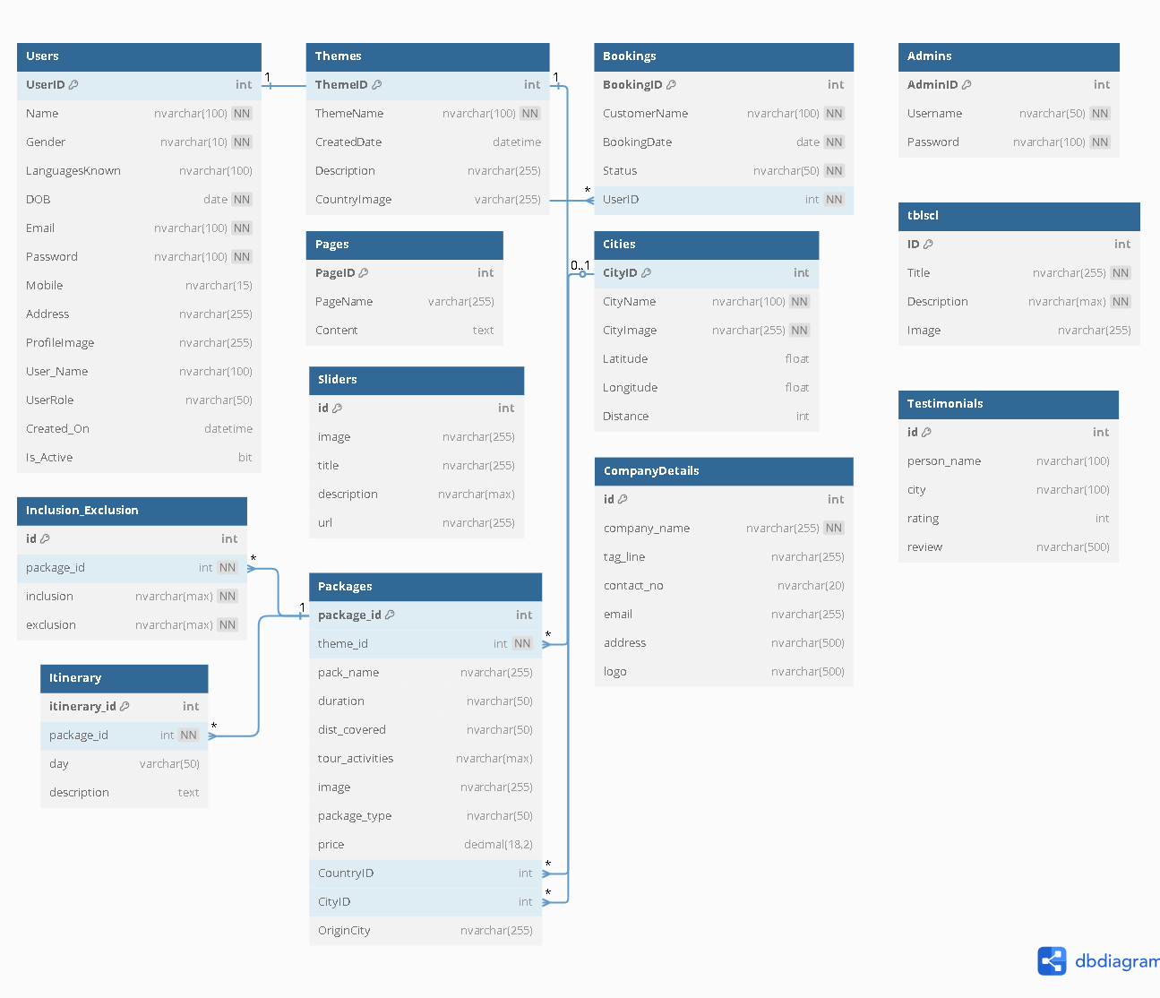

Class Diagram Tours and Travels

Use Case Diagram

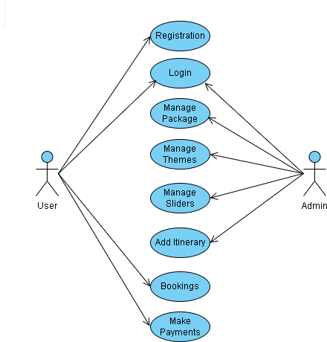

Use Case Diagram Tours and Travels

Data Dictionary

User Registration:

Fieldname | Data type | Size | Constraint | Description
Reg_id | Integer | - | Primary Key | Id of the Registration
Name | Varchar | 25 | - | Name of the user
Address | Varchar | 50 | - | Address of user
Gender | Varchar | 6 | - | Gender of user
Languages Known | Varchar | 100 | - | Languages of the user
DOB | Date | - | - | Birth date of user
Mobile | Varchar | 15 | - | Contact of the user
Email | Varchar | 50 | - | Email of user
Password | Varchar | 10 | - | Password of user
Profile | Image | - | - | Profile image of user

Themes:

Fieldname | Data type | Size | Constraint | Description
Theme_id | Integer | - | Primary Key | Id of the theme
ThemeName | Varchar | 100 | - | Name of the theme
CreatedDate | Datetime | - | - | Date of the theme
Description | varchar | 255 | - | Description of the theme
Technical Writer | Integer | - | Foreign Key | Technical writer id
Business Analyst | Integer | - | Foreign Key | Business analyst id

Booking:

Fieldname | Data type | Size | Constraint | Description
BookingID | int | - | Primary Key | Unique ID for the booking
CustomerName | nvarchar | 100 | - | Name of the customer
BookingDate | date | - | - | Date of the booking
Status | nvarchar | 50 | - | Status of the booking

Admins:

Fieldname | Data type | Size | Constraint | Description
AdminID | int | - | Primary Key | Unique ID of admin
Username | nvarchar | 50 | - | Admin username
Password | nvarchar | 100 | - | Admin password

Inclusion Exclusion:

Fieldname | Data type | Size | Constraint | Description
Id | int | - | Primary Key | Unique ID for the record
package_id | int | - | Foreign Key | Associated package ID
inclusion | nvarchar | MAX | - | List of inclusions in package
exclusion | nvarchar | MAX | - | List of exclusions in package

Pages:

Fieldname | Data type | Size | Constraint | Description
PageID | int | - | Primary Key | Unique ID of the page
PageName | varchar | 255 | - | Name of the page
Content | text | - | - | Page content

Cities:

Fieldname | Data type | Size | Constraint | Description
CityID | int | - | Primary Key | Unique city ID
CityName | nvarchar | 100 | - | Name of the city
CityImage | nvarchar | 255 | - | Image of the city
Latitude | float | - | - | Latitude of the city

TblScl:

Fieldname | Data type | Size | Constraint | Description
ID | int | - | Primary Key | Unique ID
Title | nvarchar | 255 | - | Title of the section
Description | nvarchar | MAX | - | Description content
Image | nvarchar | 255 | - | Image associated

Packages:

Fieldname | Data type | Size | Constraint | Description
package_id | int | - | Primary Key | Unique package ID
theme_id | int | - | Foreign Key | Associated theme ID
pack_name | nvarchar | 255 | - | Name of the package
duration | nvarchar | 50 | - | Duration of the package
dist_covered | nvarchar | 50 | - | Distance covered
tour_activities | nvarchar | MAX | - | Activities included
Image | nvarchar | 255 | - | Image for package
package_type | nvarchar | 50 | - | Type of the package
Price | decimal | 18,2 | - | Price of the package
country_id | int | - | Foreign Key | Country of package
CityID | int | - | Foreign Key | Associated city ID
OriginCity | nvarchar | 255 | - | Origin city of travel

Sliders:

Fieldname | Data type | Size | Constraint | Description
Id | int | - | Primary Key | Unique slider ID
Image | nvarchar | 255 | - | Image for slider
Title | nvarchar | 255 | - | Title for the slider
description | nvarchar | MAX | - | Description of the slider
url | nvarchar | 255 | - | Redirect URL

CompanyDetails:

Fieldname | Data type | Size | Constraint | Description
Id | int | - | Primary Key | Unique ID
company_name | nvarchar | 255 | - | Name of the company
tag_line | nvarchar | 255 | - | Tagline of the company
contact_no | nvarchar | 20 | - | Contact number
Email | nvarchar | 255 | - | Email ID
Address | nvarchar | 500 | - | Company address
Logo | nvarchar | 500 | - | Company logo

AboutUs:

Fieldname | Data type | Size | Constraint | Description
Id | int | - | Primary Key | Unique About Us section
Content1 | nvarchar | MAX | - | First content section
Content2 | nvarchar | MAX | - | Second content section
Image1 | nvarchar | 500 | - | First image
Image2 | nvarchar | 500 | - | Second image

Testimonials:

Fieldname | Data type | Size | Constraint | Description
id | int | - | Primary Key | Unique testimonial ID
person_name | nvarchar | 100 | - | Name of the person
city | nvarchar | 100 | - | City of the person
rating | int | - | - | Rating given
review | nvarchar | 500 | - | Review description

UserPackages:

Fieldname | Data type | Size | Constraint | Description
PackageID | int | - | Primary Key | Unique package ID
PackageName | nvarchar | 255 | - | Name of the package
Price | decimal | 10,2 | - | Price of the package
Description | nvarchar | MAX | - | Description of the package
ImageUrl | nvarchar | 255 | - | Image of the package

Itinerary:

Fieldname | Data type | Size | Constraint | Description
itinerary_id | int | - | Primary Key | Unique itinerary ID
package_id | int | - | Foreign Key | Associated package ID
day | varchar | 50 | - | Day number of itinerary
description | text | - | - | Details of that day

​Snap Shots

Home Page
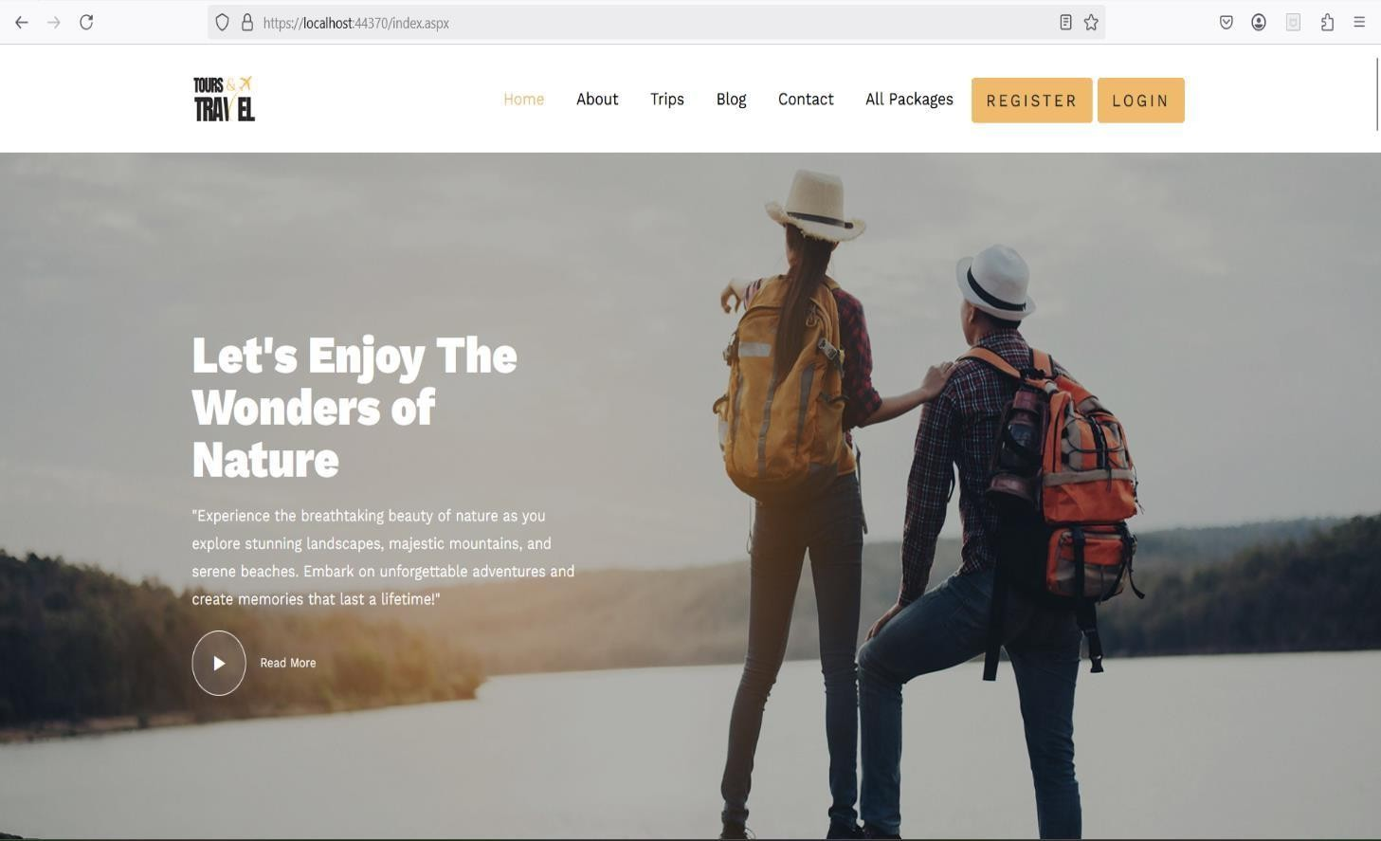
  - Registration Page
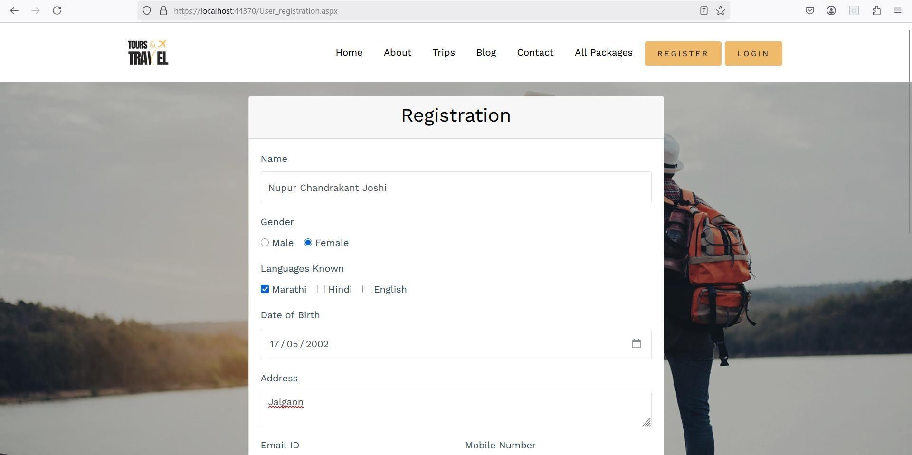

  - Login page
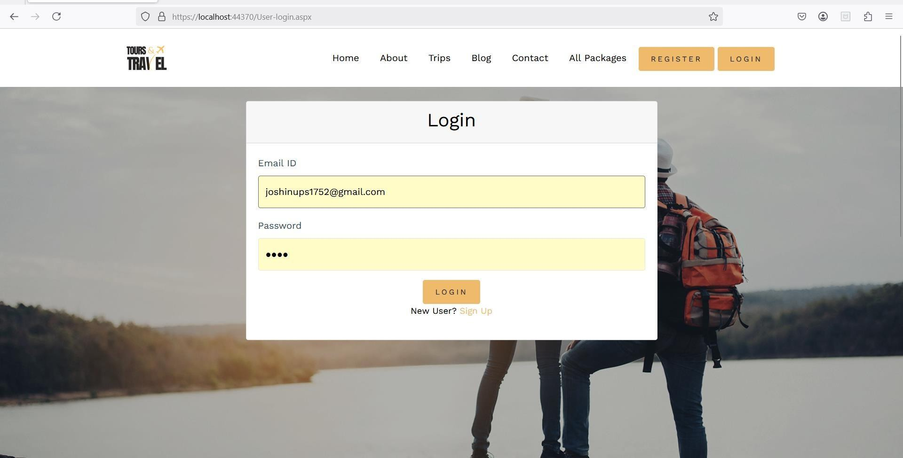
e

  - Profile page
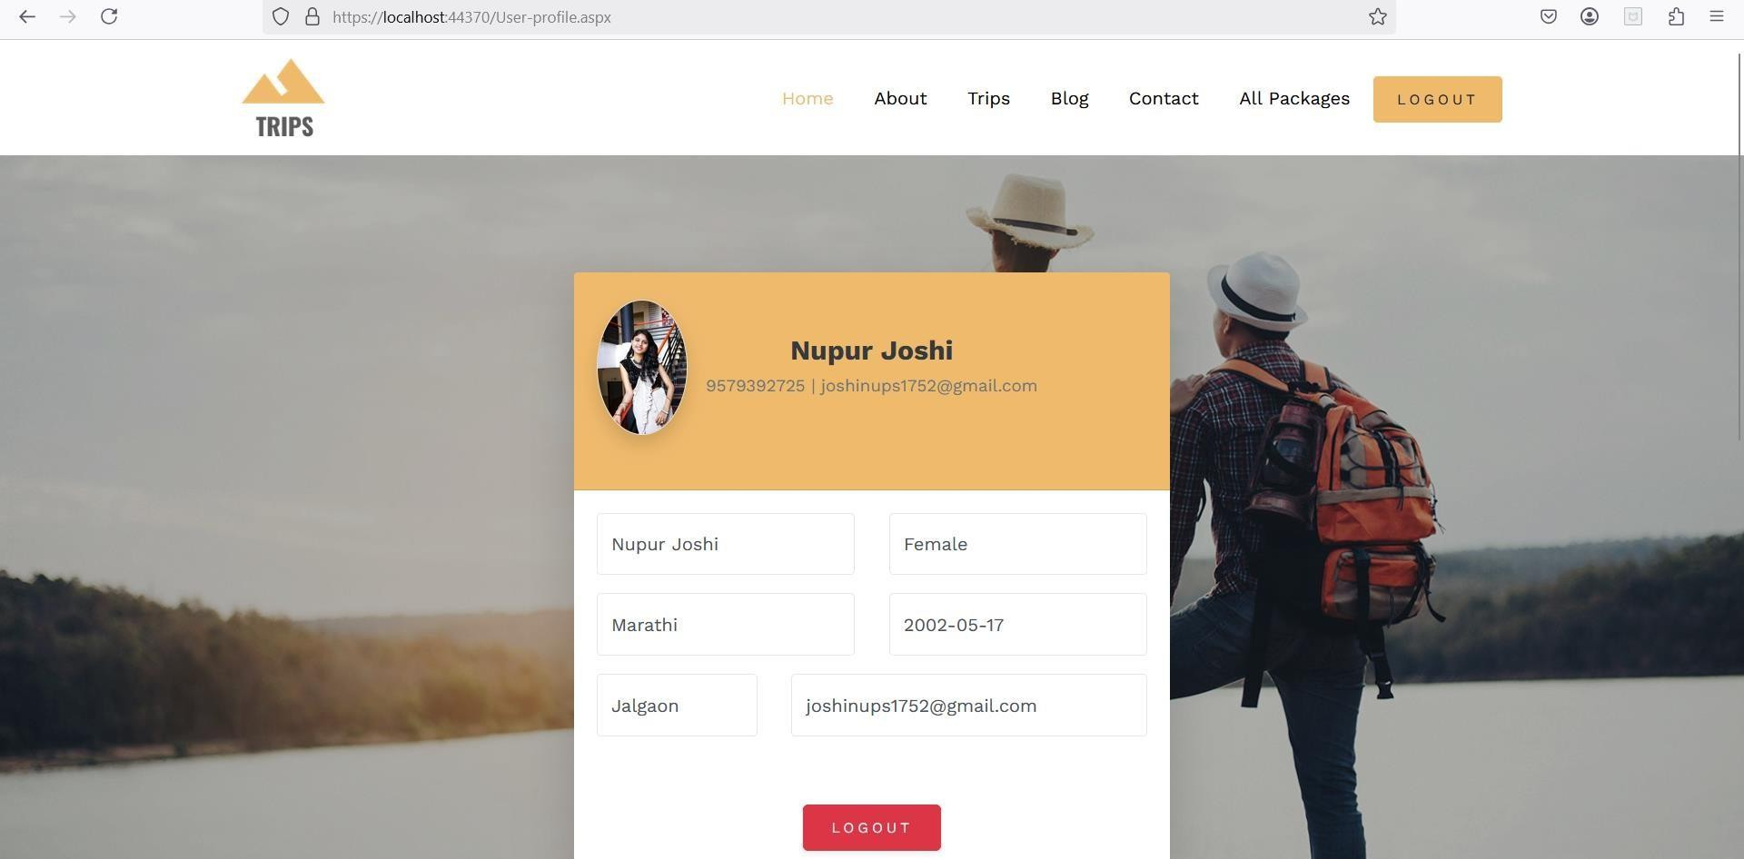

  - AboutUs page
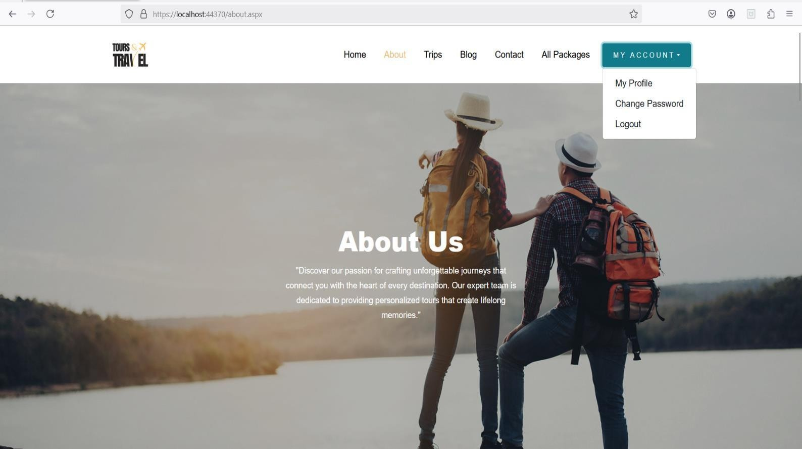
  - Trips page
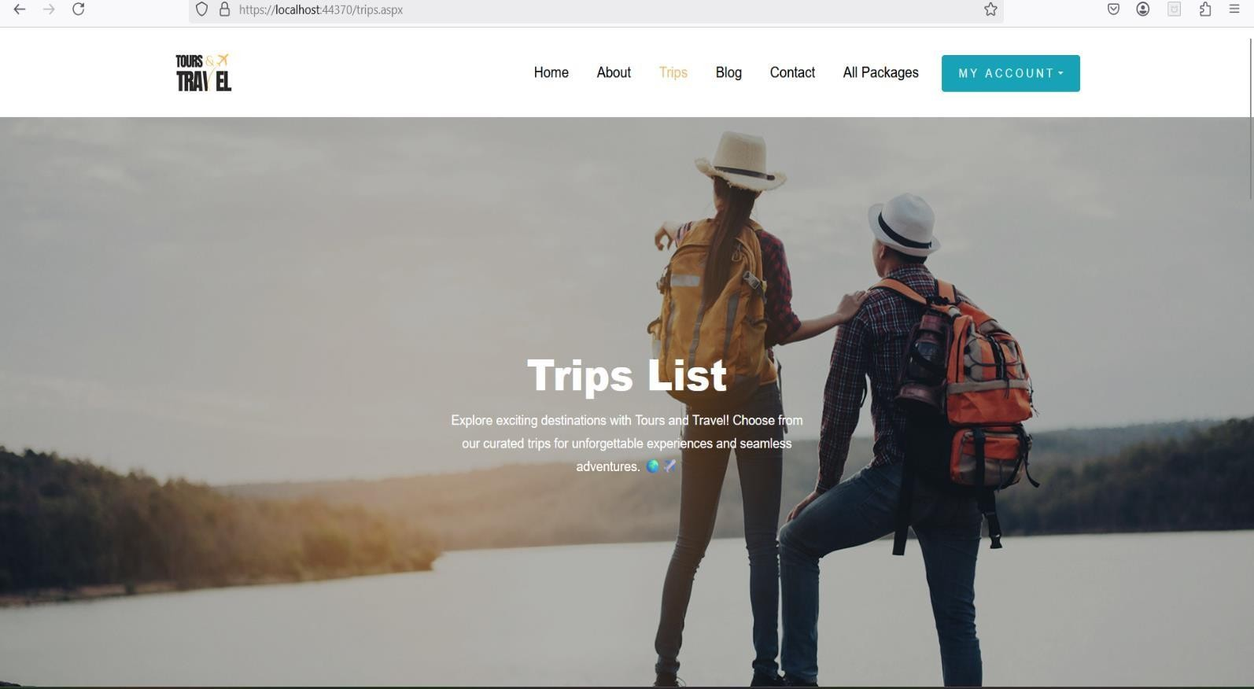

  - Blog page
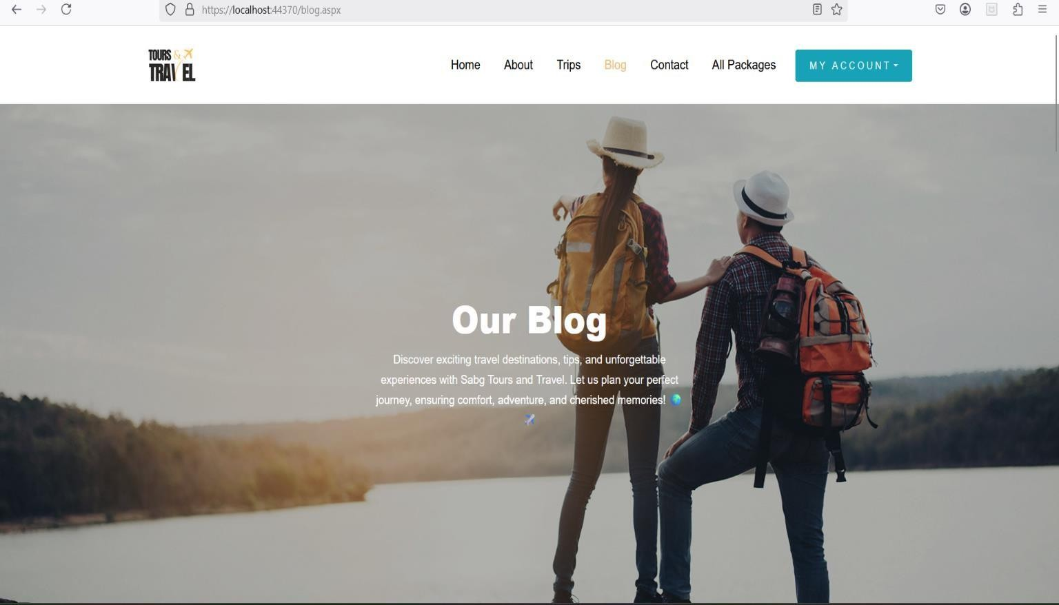
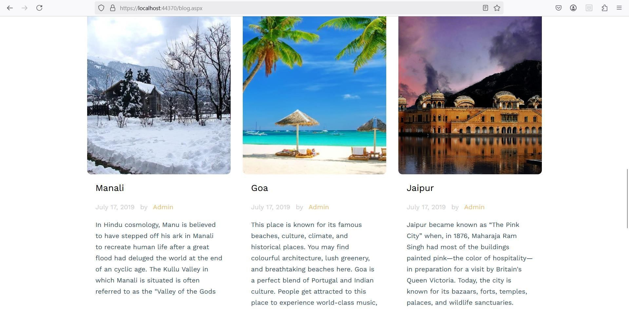

  - Contact Page
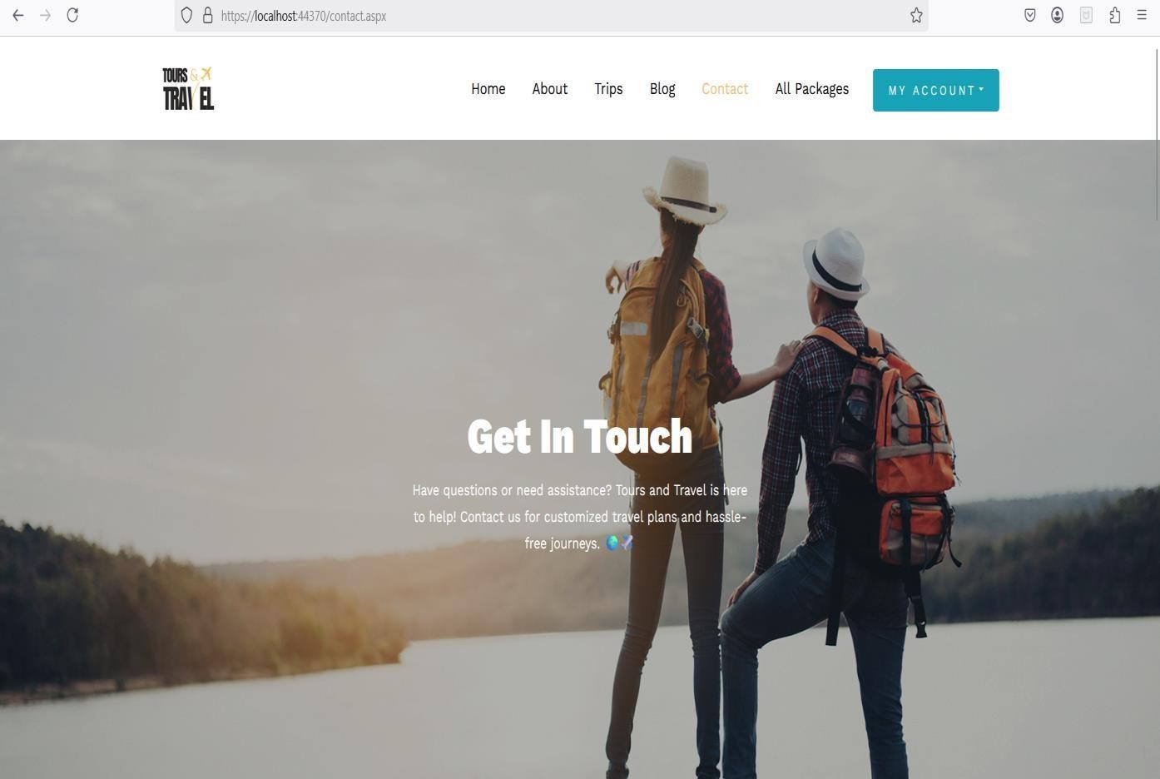
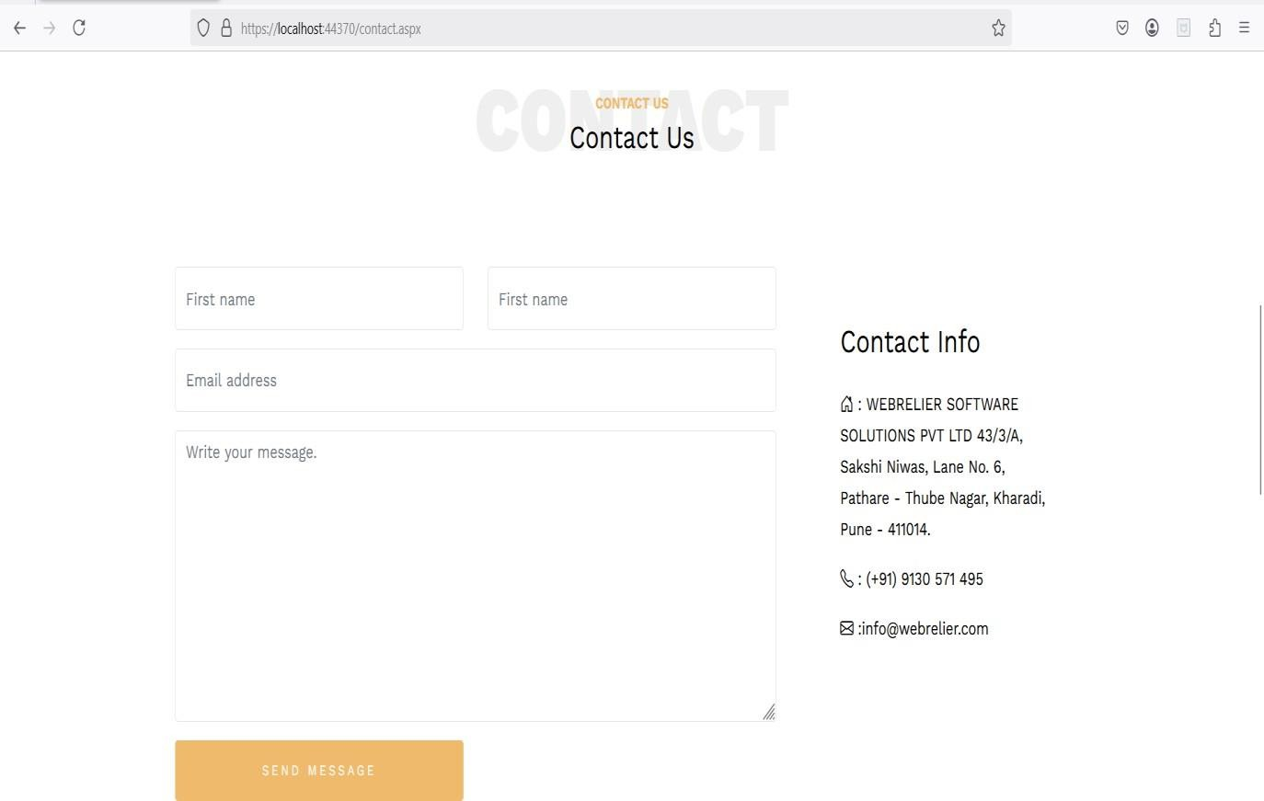

Admin Panel
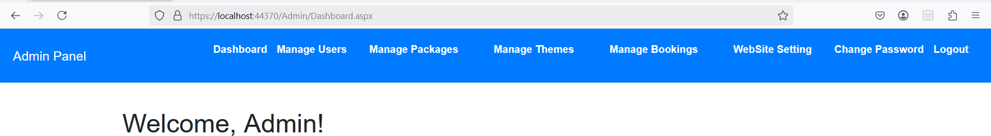

  - Manage User
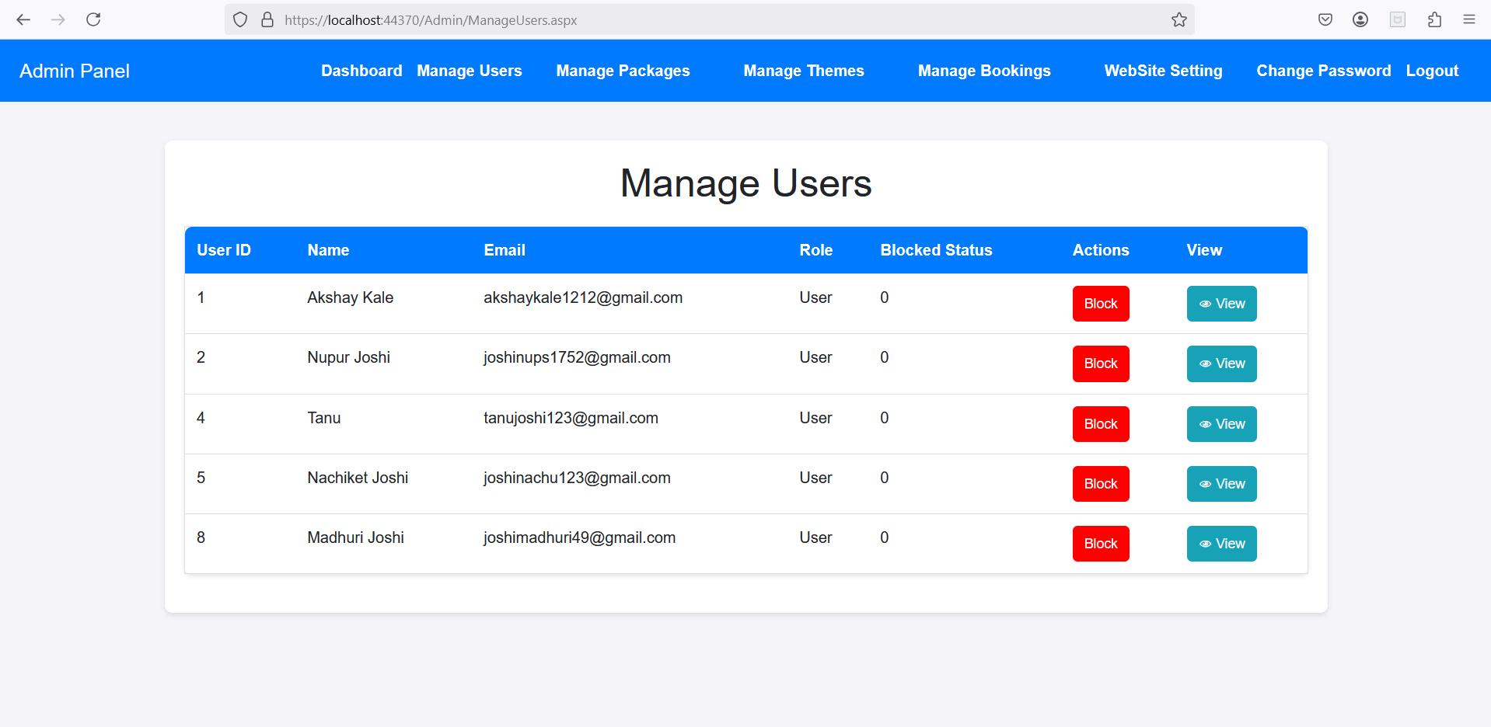
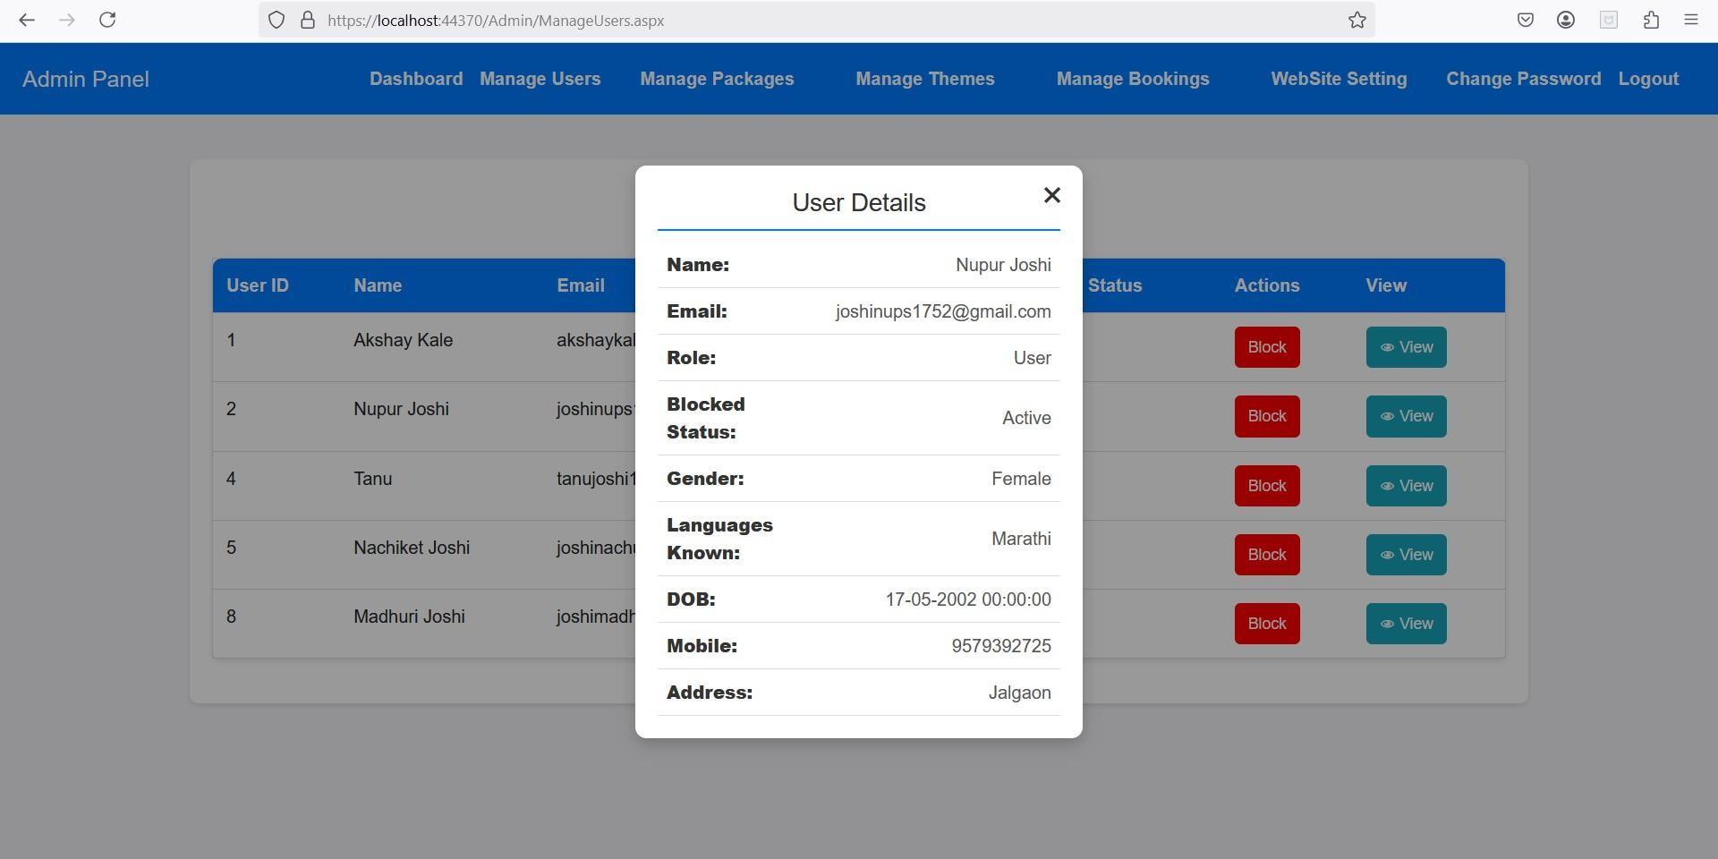

  - Manage Package
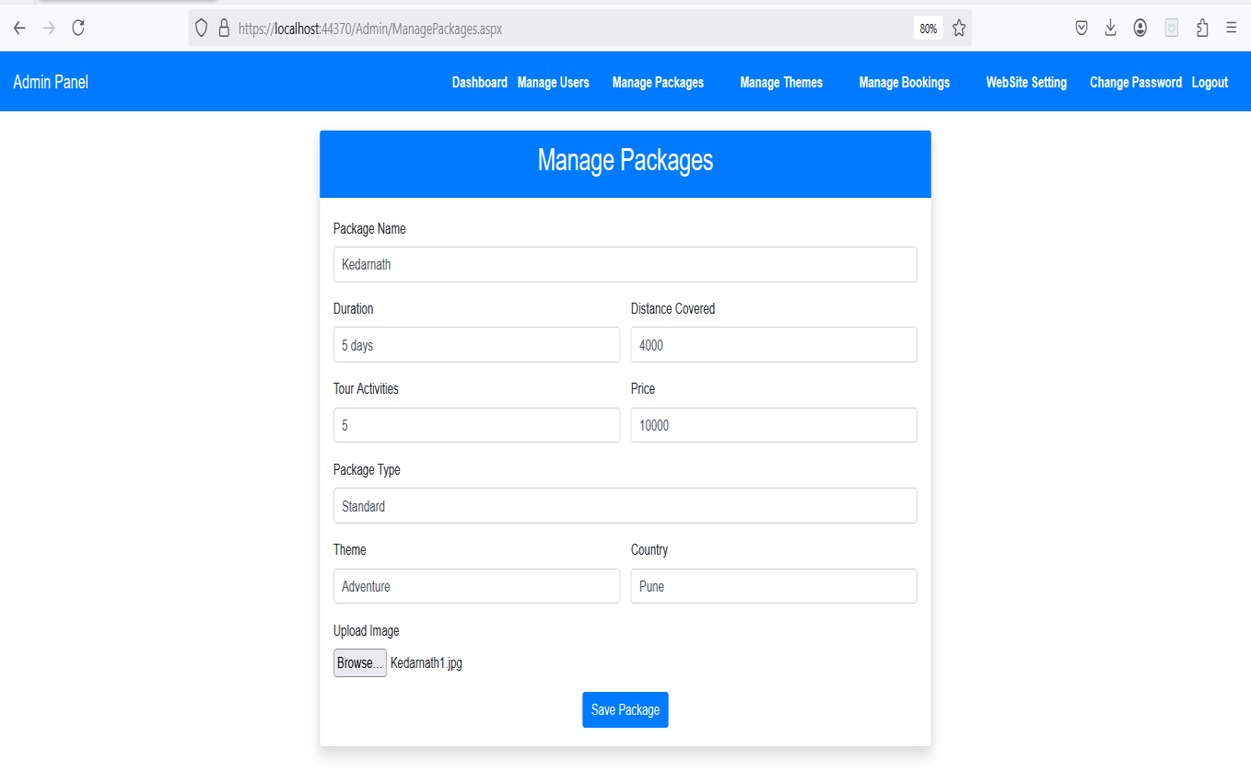
  - PackageList Page
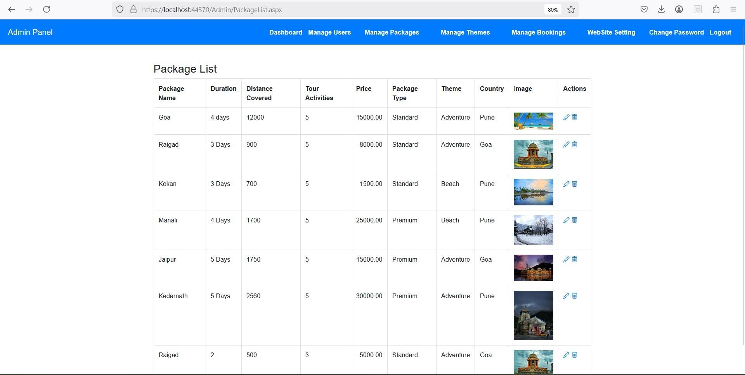

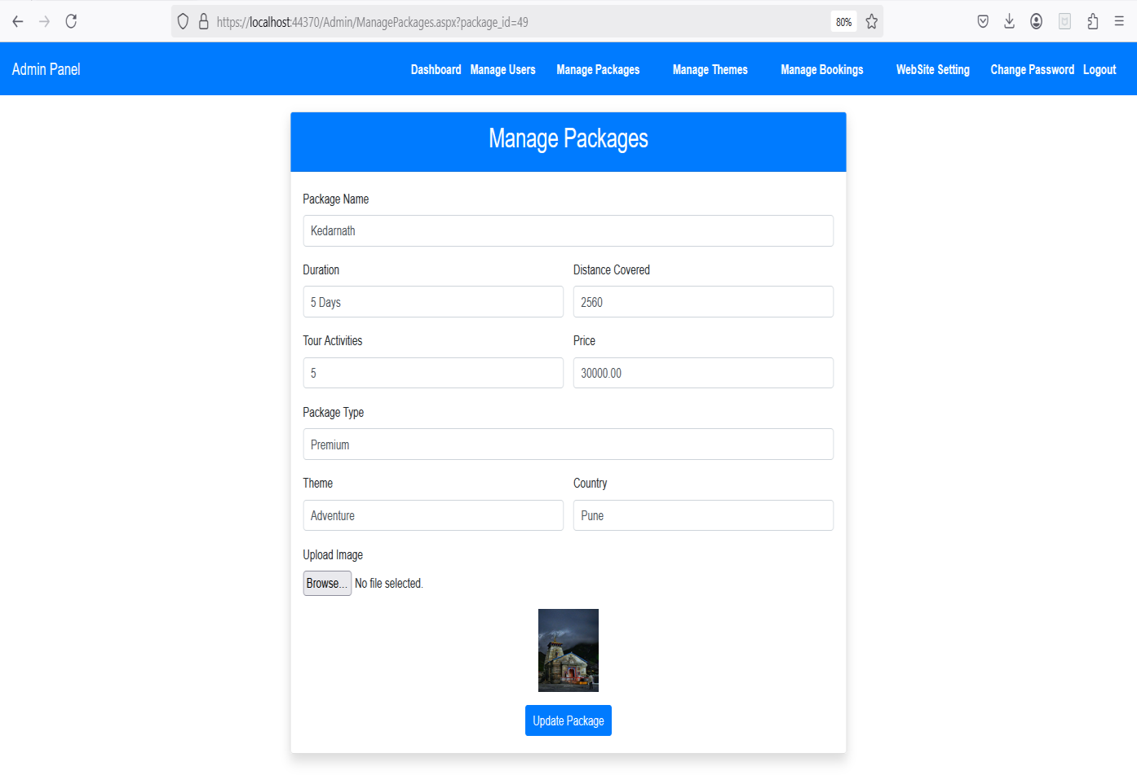
  - ManageTheme
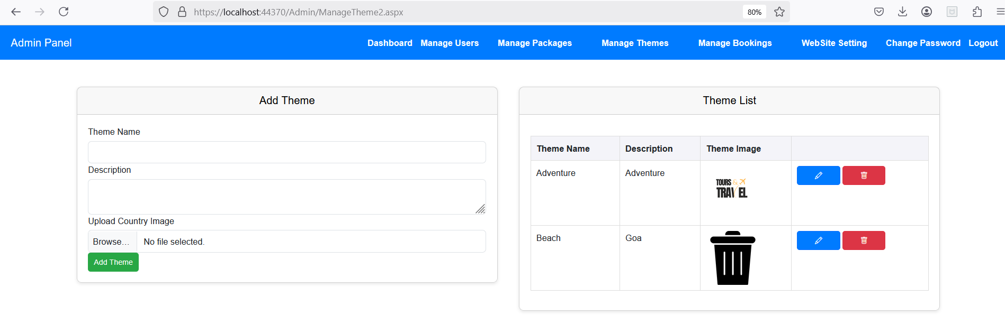

  - ManageCountry
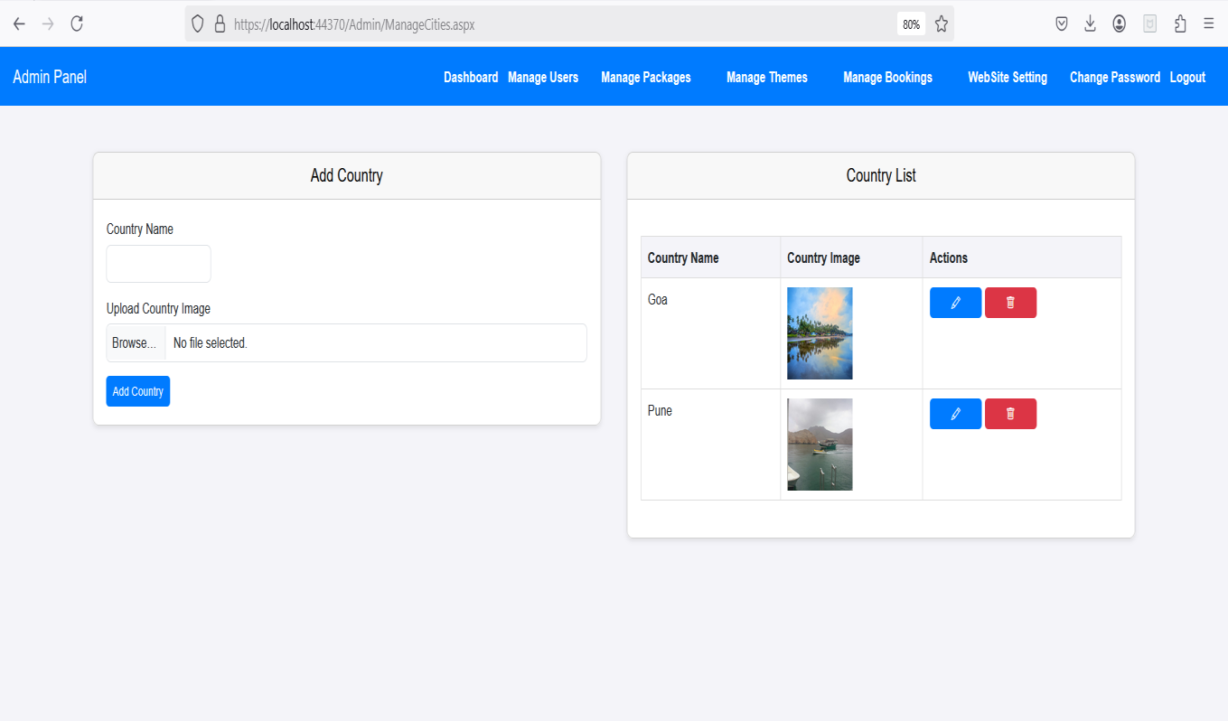
  - Website Setting
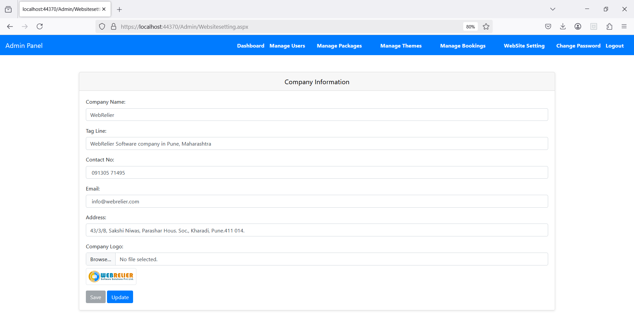

  - Manage Slider
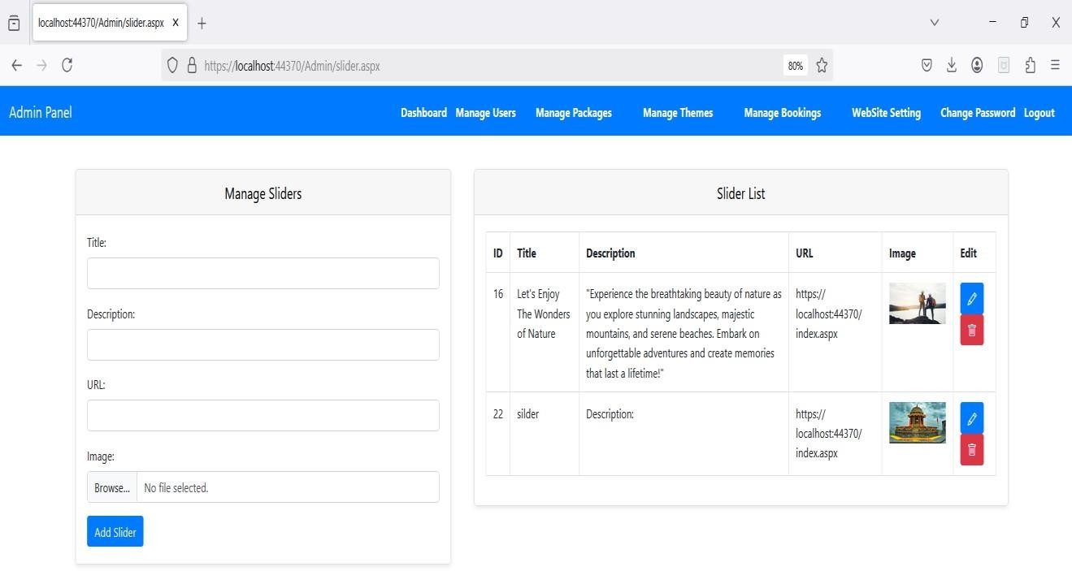
  - About Us(Admin)
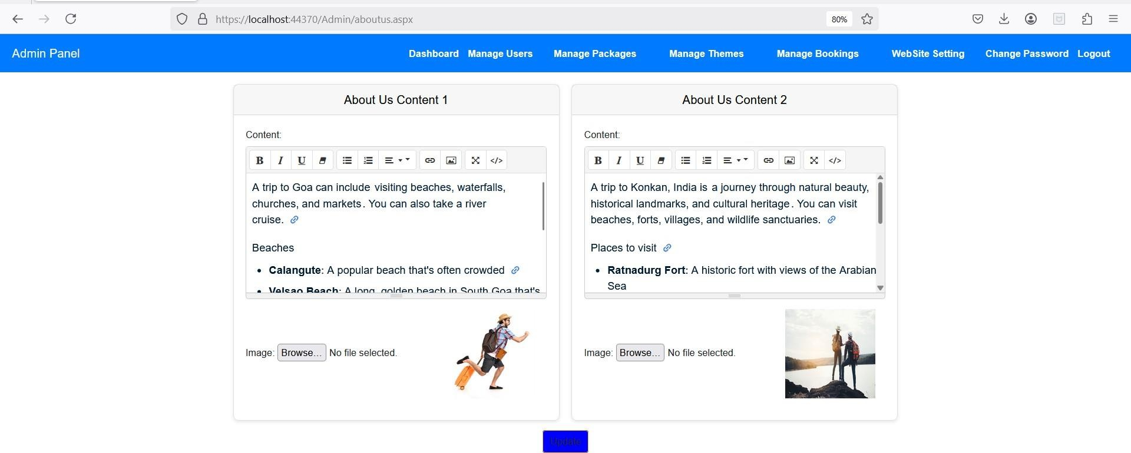

6. 18.Testimonials List
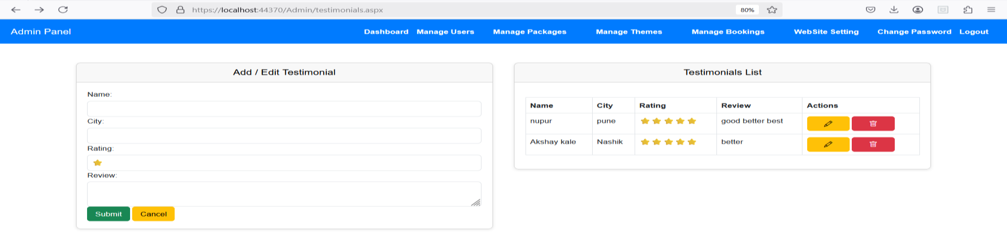

6.19.Change Password
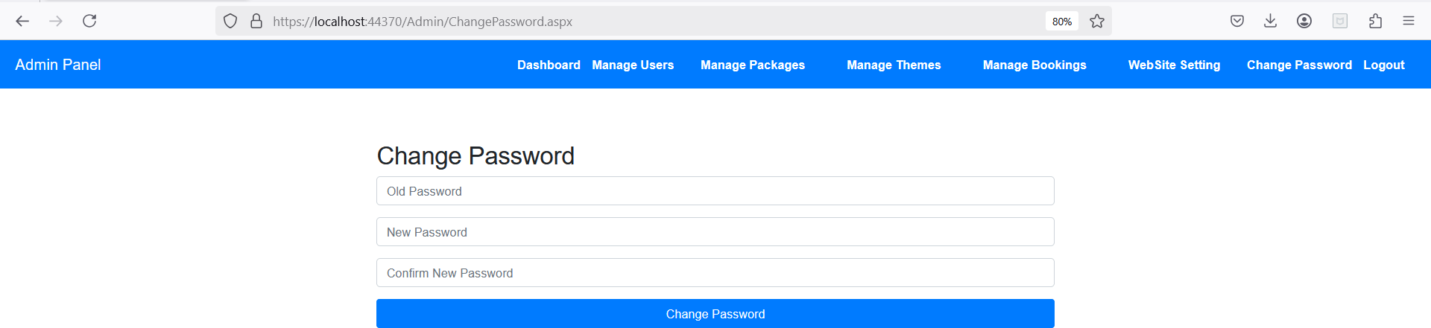

Testing Tools

Testing is important from the point of view of accurate functioning of the project. There are many testing measures and tools available to test a project.
Basic tools used to test this project are:
- Black Box Testing.
- White Box Testing
- GUI Testing

Black Box Testing:
It is a method of software testing that tests the functionality of an application as opposed to its internal structures or workings. Specific knowledge of the application’s code/internal structure and programming language in general is not required. The tester is only aware of what the software is supposed to do, but not how i.e. when he enters a certain input, he gets certain output; without being aware of how the output was produced. Tests cases are built around specifications and requirements, i.e., what the application is supposed to do. It uses external descriptions of the software, including specifications, requirements and designs to derive test cases. These test designers select valid and invalid inputs and determine the correct output. There is knowledge of the test object’s internal structure. This method of test can be applied to all levels of software testing: Unit, Integration, System and Acceptance. It typically comprises most if not all testing at higher levels, but can also dominate unit testing as well.

The advantages of this type of testing include:
    - The test is unbiased because the designer and the tester are independent of each other.
    - The tester does not need knowledge of any specific programming languages.
    - The test is done from the point of view of the user, not designer.
The disadvantages of this type of testing include:
    - The case can be redundant if the software designer has already run a test case.
    - The test cases are difficult to design.

White Box Testing:
White box testing is a method of testing software that tests internal structures or workings of an application, as opposed to its functionality. In white-box testing an internal perspective of the system, as well as programming skills, are required and used to design the test cases. The tester chooses input to exercise paths through the code and determine the appropriate outputs. While white-box testing can be applied at the unit, integration and system levels of the software testing process, it is usually done at unit level. It can test paths within a unit, paths between units during integration, and between subsystems during a system level test. Though this method of test design can uncover many errors or problems, it might not detect unimplemented parts of the specification or missing requirements.
White-Box test design techniques include:
    - Control flow Testing
    - Data flow Testing
    - Branch Testing
    - Path Testing For a complete software examination, both white box and black box tests are required.

Graphical User Interface Testing:
It is the process of testing a product’s graphical user interface to ensure it meets its written specifications. This is normally done through the use of a variety of test cases. It checks only the user friendliness.
The creation of the user interface is less time consuming for the user but more complex for the programmer.
It must be tested for its sole purpose.

This test must be carried out to ensure:
    - Windows open properly.
    - All data contents are properly addressable.
    - All the graphical elements are available and displayed. Multiple or incorrect mouse click do not produce side effects

Scope of Project

The scope of a Tours and Travels in Java can vary depending on the specific requirements and objectives of the project. However, here's a general outline of what the project might include:

User Authentication and Authorization:
  - Implement a secure login system for customers, administrators, and travel agents with role- based access control.
  - User registration with email verification and password hashing for security.
  - Different access levels:
    - Admin: Manages packages, bookings, and system settings.
    - Travel Agents: Handles customer inquiries and trip customization.
    - Customers: Browse packages, book tours, and make payments.

Tour Package Management:
  - Add, update, delete, and view various travel packages.
  - Packages include destination details, itinerary, price, duration, activities, images, and inclusions/exclusions.
  - Categorization by themes (Adventure, Luxury, Family, Honeymoon, etc.).
  - Integration of special offers and discounts.

Booking and Payment System:
  - Online tour booking with real-time availability checks.
  - Secure payment gateway integration (Credit Card, UPI, PayPal, Net Banking).
  - Booking confirmation via email and SMS notifications.
  - Refund and cancellation policies with automated processing.

Destination and City Management:
  - Manage cities, attractions, and points of interest for easy tour planning.
  - Add images, travel distances, climate details, and travel guidelines.
  - Integrate with Google Maps for real-time location tracking.

Itinerary Planning and Customization:
  - Generate day-wise itineraries for each package.
  - Allow customers to request customized itineraries based on preferences.
  - Option to add extra activities, excursions, or hotel upgrades.

User Reviews and Testimonials:
  - Customers can rate and review tour packages.
  - Display testimonials on the website for credibility.
  - Admin can moderate and respond to reviews.

Notifications and Alerts:
  - Automated booking confirmations, reminders, and promotional offers via Email/SMS.
  - Alerts for pending payments, trip updates, and itinerary changes.

Reports and Analytics:
  - Generate reports on sales, bookings, customer trends, and revenue.
  - Analyses popular destinations and package performance.
  - Visual representation using charts, graphs, and dashboards.

Admin and Travel Agent Panel:
  - Centralized dashboard for managing bookings, users, payments, and packages.
  - Assign travel agents to specific bookings and customer queries.
  - Manage hotel, transport, and activity partners.

Security and Compliance:
  - Secure authentication and authorization with encrypted user data.
  - Protection against SQL injection, cross-site scripting, and unauthorized access.
  - Ensure GDPR compliance for customer data privacy.

Scalability and Performance Optimization:
  - Cloud-based deployment for handling large user traffic.
  - Optimize database queries and caching for fast loading speeds.
  - Load balancing for handling peak booking seasons.

User-Friendly Interface and Mobile Compatibility:
  - Responsive web-based application accessible on mobile and desktop.
  - Easy navigation for customers to search and book trips seamlessly.
  - Mobile app integration (optional) for better accessibility.

Documentation and Training:
  - Provide user manuals and admin guides for smooth system operations.
  - Conduct training sessions for travel agents and administrators.

9.Future Enhancement

To enhance the functionality and improve the user experience of a Tours and Travels, the following future enhancements can be considered:

Performance Optimization
  - Continuously optimize system performance by identifying and resolving slow database queries, improving response times, and reducing server load.
  - Implement caching mechanisms for frequently accessed data (e.g., popular destinations, tour packages).
  - Use load balancing to ensure smooth operations during peak booking seasons.

Mobile Application
  - Develop a mobile app to allow users to browse travel packages, book tours, and manage their itineraries on the go.
  - Provide real-time notifications, GPS tracking of booked tours, and digital tickets.
  - Enable offline access for essential details like hotel bookings and itineraries.

Customer Self-Service Portal
  - Create a self-service portal where customers can manage bookings, make payments, request cancellations/refunds, and track their travel history.
  - Provide access to download invoices, e-tickets, and travel guidelines.
  - Allow customers to request special accommodations or customized tours.

Integration with Travel and Booking Platforms
  - Integrate with flight and hotel booking systems (Expedia, Skyscanner, Booking.com, etc.) for seamless trip planning.
  - Enable real-time pricing updates and availability for hotels, flights, and activities.
  - API integrations with Google Maps for navigation and distance calculations.

Advanced Reporting and Analytics
  - Implement real-time sales and booking reports for travel agencies.
  - Use predictive analytics to suggest travel trends based on customer preferences.
  - Generate tourist behavior insights, such as most visited locations and peak seasons.

Customer Feedback and Surveys
  - Enable customers to leave reviews and ratings for booked trips.

  - Conduct post-trip surveys to gather feedback on tour guides, accommodation, and overall experience.
  - Use feedback to improve services and offer better travel recommendations.

Loyalty and Rewards System
  - Implement a loyalty program where customers earn points for every booking.
  - Allow customers to redeem points for discounts on future trips, upgrades, or exclusive experiences.
  - Offer referral bonuses for customers who invite friends to use the platform.

AI-Powered Travel Recommendations
  - Use artificial intelligence (AI) to suggest destinations based on a customer’s travel history and preferences.
  - Implement a chatbot for travel assistance, answering FAQs and helping customers choose suitable packages.
  - Use dynamic pricing strategies based on demand, season, and user engagement.

GDPR Compliance and Data Privacy
  - Ensure compliance with GDPR, CCPA, and other data protection regulations.
  - Secure customer data with encryption techniques and implement secure payment gateways.
  - Regular security audits to prevent data breaches and cyber threats.

AI-Powered Chat Support & Virtual Assistance
  - Implement AI chatbots to provide 24/7 customer support for booking inquiries, cancellation requests, and package recommendations.
  - Offer language translation features for international travellers.

Feedback Loop and Continuous Improvement
  - Establish a system to collect feedback from customers, travel agents, and administrators.
  - Conduct A/B testing to improve user interface (UI) and overall platform experience.
  - Update travel packages and itineraries based on trending destinations and seasonal offers.

Customization and Extensibility
  - Allow agencies to customize travel packages based on customer requirements.
  - Provide an API for third-party integrations with external booking systems.
  - Support white-label solutions for travel agencies to use the platform with their branding.

Conclusion

The Tours and Travels provides a comprehensive and efficient solution for managing travel bookings, tour packages, customer interactions, and administrative tasks. By integrating essential features such as user authentication, package management, itinerary planning, and payment processing, the system enhances user experience and simplifies operations for both travellers and administrators.
Through its dynamic and user-friendly interface, built with ASP.NET (C#), HTML, CSS, and Bootstrap, the system ensures seamless navigation and responsiveness across different devices. Additionally, features such as secure login sessions, automated booking confirmations, and interactive itinerary displays make the platform reliable and efficient for end users.
Looking ahead, the system has room for future enhancements, including AI-driven recommendations, advanced analytics for customer insights, mobile application support, and seamless third-party integrations with popular travel APIs. These improvements will further enhance usability, scalability, and customer engagement, positioning the system as a competitive and modern solution in the travel industry.
Ultimately, the Tours and Travels serves as a powerful tool for travel businesses, helping them streamline operations, improve customer satisfaction, and expand their market reach. With continuous updates and enhancements, the system will remain adaptable to the evolving needs of the tourism industry, ensuring long-term growth and success.

